Intro
As we reflect upon 2023 through the creation of this annual report, the words that come to mind are resilience and excitement. Our resilience has been demonstrated since 2020 as we worked through COVID and the subsequent “Great Resignation”. Positive Alternatives additionally became accredited and certified as Qualified Residential Treatment (QRTP) programs and rolled out new programming as required by QRTP certification. The group homes thrived in 2023 with the low group size and high staff to resident ratio allowed by QRTP funding.

Community Based Services also gained momentum on a Strategic Plan created to bounce back from the program’s COVID closure. The program flourished and grew in 2023 with higher billable hours than seen in several years, and a new focus to improve the experience of families served with improved family-friendly spaces.

Additionally, we are excited that our work on the organization’s new Strategic Plan began, with goals to build upon our strengths and improve our programs’ quality and the experiences of staff. Noteworthy accomplishments of this plan include the rollout of a new logo and branding, and a contract to open a new group home in Eastern Wisconsin in 2024.

The accomplishments of 2023 have us excited for 2024 and beyond as we continue to strengthen our programs, accomplish our strategic goals, and expand our services. Our employees, board of directors, clients, and the community have been integral to our success, and we rely on these partners as we continue this momentum into the future. The following is an exhaustive report of Positive Alternatives’ operations in 2023. A more condensed, public-facing report is also available for a quicker snapshot of Positive Alternatives’ accomplishments.

GH STATS
 | Menomonie | River Falls | Amery | Wisconsin Rapids | Marathon County | Average | 2023 Total | 2022 Total | 2021 Total
Number of Intakes | 26 | 20 | 11 | 19 | 46 | 24.4 | 112 | 99 | 163
Total number of long-term placements | 13 | 15 | 6 | 19 | 9 | 12.4 | 62 | 65 | 84
Total number of short term/Respite placements | 13 | 5 | 5 | 0 | 37 | 12 | 60 | 34 | 79
Average age of clients served | 14.89 | 15.27 | 15.3 | 16.5 | 15.63 | 15.54 |  | -
Average daily census for year | 5.12 | 4.78 | 4.02 | 4.77 | 3.65 | 4.47 | 22.34 | 22.46 | 21.84
Average daily census paid for year | 5.59 | 4.91 | 4.64 | 4.8 | 4.16 | 4.82 | 24.10 | 23.71 | 26.3
Police contacts | 19 | 76 | 47 | 27 | 18 | 37.4 | 187 | 108 | 160
Medication errors | 4 | 6 | 2 | 2 | 2 | 3.2 | 16 | 10 | 12

Still accredited and QRTP

CBS STATS

Mentoring
COUNTIES SERVED | 2023  TOTAL CLIENTS | 2023 TOTAL BILLABLE HOURS
DUNN | 13 | 701.5
EAU CLAIRE | 1 | 30.25
IRIS | 1 | 64
PEPIN | -- | -
PASS TOTAL | 15 | 795.75
CHIPPEWA CCS | 7 | 790:35
EAU CLAIRE CCS | 2 | 383:43
ST. CROIX CCS | 5 | 504:54
JEFFERSON CCS | - | -
CCS TOTAL | 14 | 1,679:12

Supervised Visits
COUNTIES SERVED | 2023  TOTAL CLIENTS | 2023 TOTAL BILLABLE HOURS
BUFFALO | - | -
CLARK | 2 | 126.25
DOOR | 1 | 18.75
DUNN | 7 | 238.75
JEFFERSON | - | -
MARATHON | 1 | 23.5
PEPIN | - | -
PIERCE | - | -
PRIVATE PAY | 6 | 266.5
ST. CROIX | 5 | 970.5
SUPERVISED VISIT TOTALS | 22 | 1,644.25

Officer and leadership experience
Fun fact at the time of this report: the 10 most tenured team members at Positive Alternatives represent 124 years of combined service across multiple positions and levels of the agency!

Additionally, many members of the Leadership Team are also among those 10 most tenured individuals mentioned above. When considering all service to Positive Alternatives, the
Leadership Team has a combined 94 years of service and experience at Positive Alternatives! The Officer roles— Kelli Kamholz - President/CEO, Jeremy Hernandez -Vice President/COO, and Denise Horstman -Vice President/CFO—represent a combined 46 years of agency service and experience. Wow!

Employment Stats
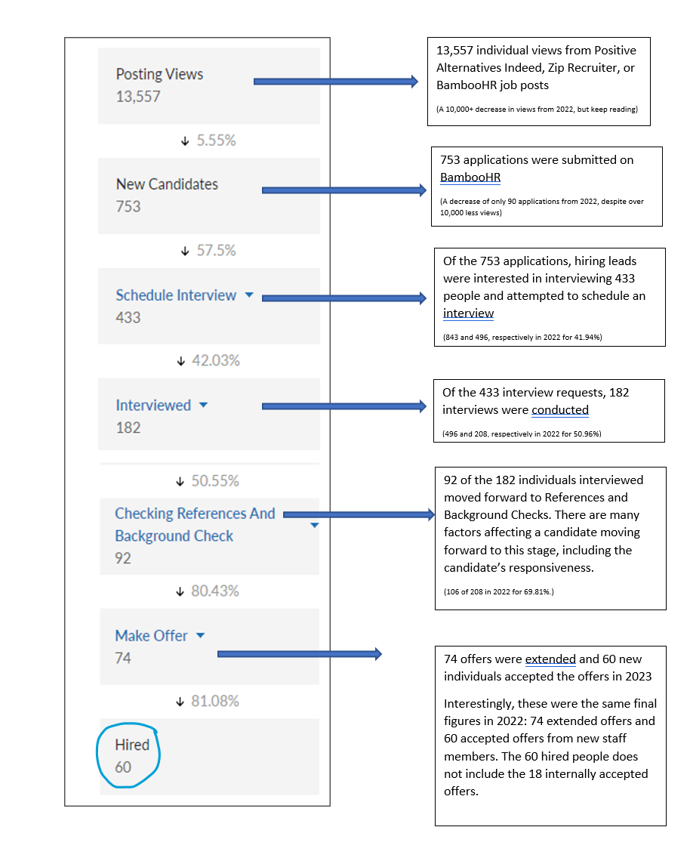
Of the 81 team members on staff at the end of 2023, 25% of the workforce has been employed with Positive Alternatives for three or more years.

Conclusion
As we conclude this annual report, the unwavering resilience of Positive Alternatives leaves us excited for the future. Not only has the organization survived, but we have thrived and adapted, and 2024 is looking to be a great year.

In 2024, Positive Alternatives will celebrate 50 years of service to youth and families in Wisconsin. This event will be celebrated across all the communities we serve as we reflect upon the work we have done and celebrate the commitment of our partners and the impact the organization has had upon the youth and families we serve, our employees, and our community.

Thank you to you, our partner, for your role in Positive Alternatives’ success. We look forward to our partnership for years to come!

